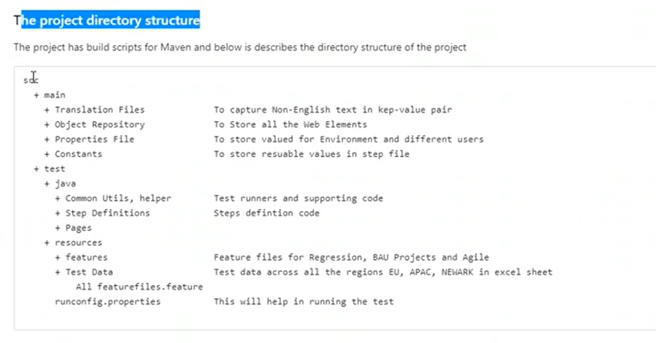
We will make changes to step definitions, pages, features only
Repository has all locators xpath
Naming format to follow – xxxSteps.java if pages PDPPages
- Create feature file with same statements
- Create objs.java based on pages. List_ALL, “xpath”
- Create stepDefiition is not present
- Update tag to stepRunner file and Run
- To change browser runConfig properties
To verify element , go by /structure nav
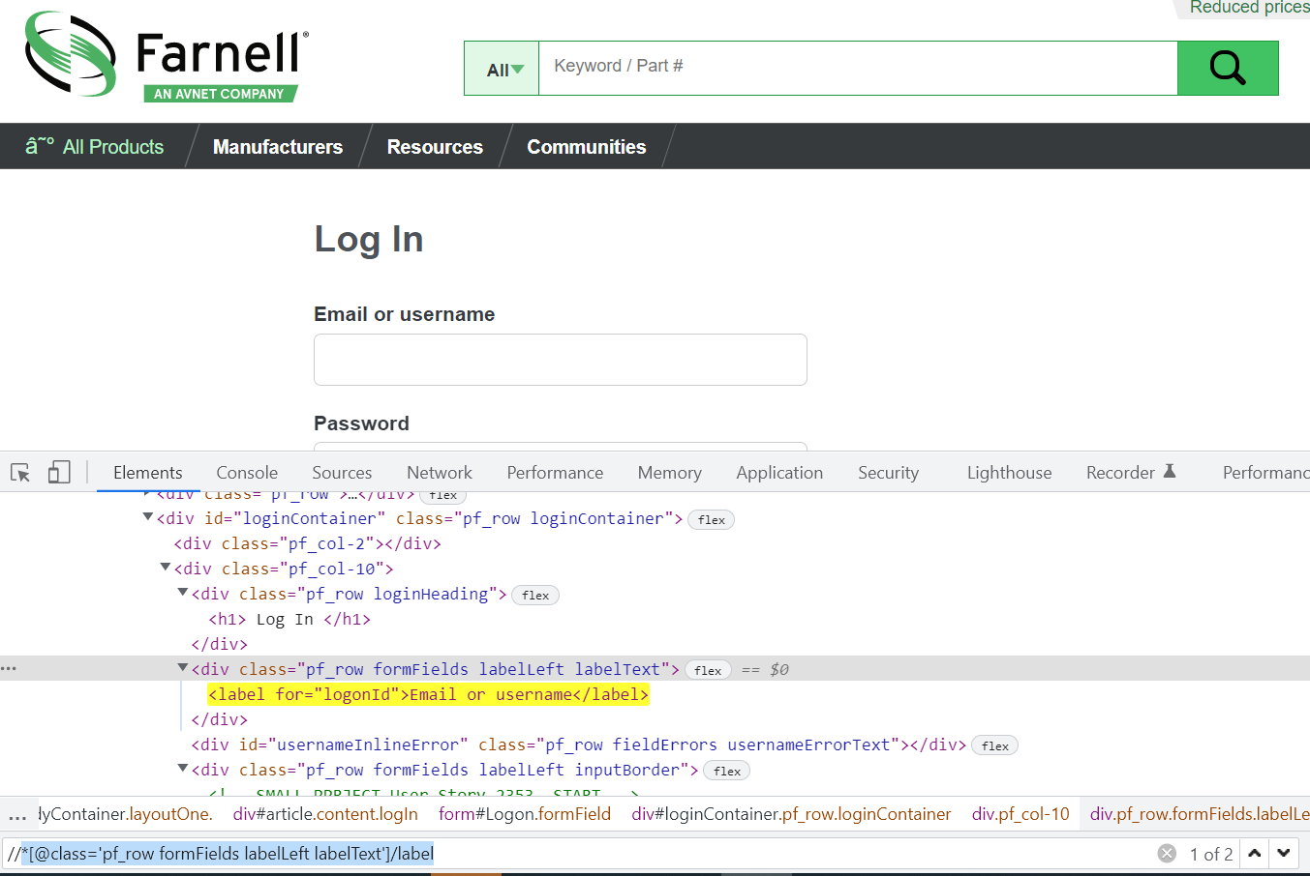
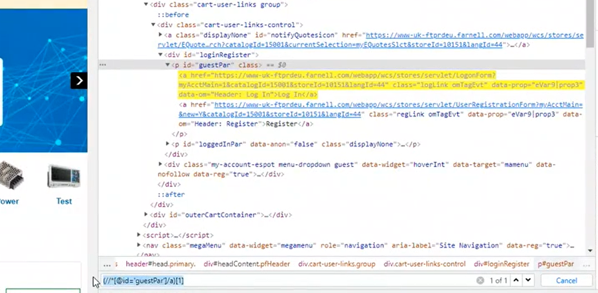

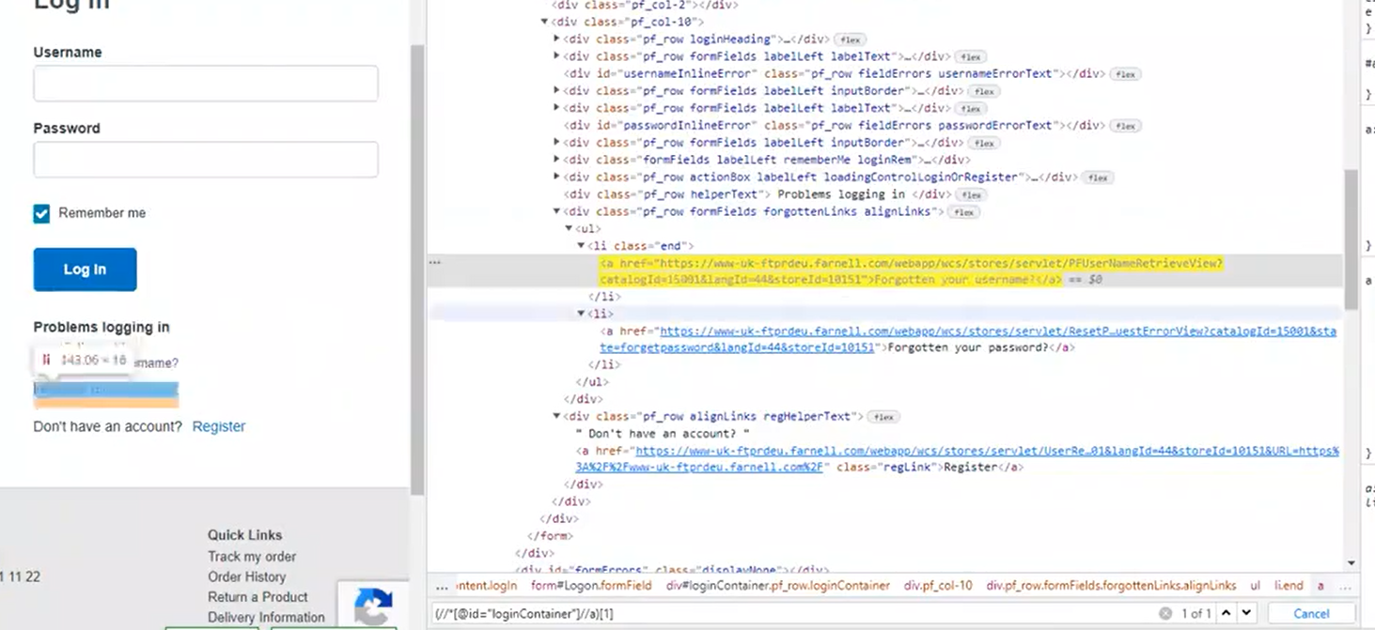

install new eclipe 20.12
cucumber plug in marketplace
window prefernce -> maven -> user setting
import project

regex -- .* value “( for arguments
WebDriver will simulate same way like in real user.
JavaScript, it will work because the event is delivered directly to the element, irrespective of visibility.
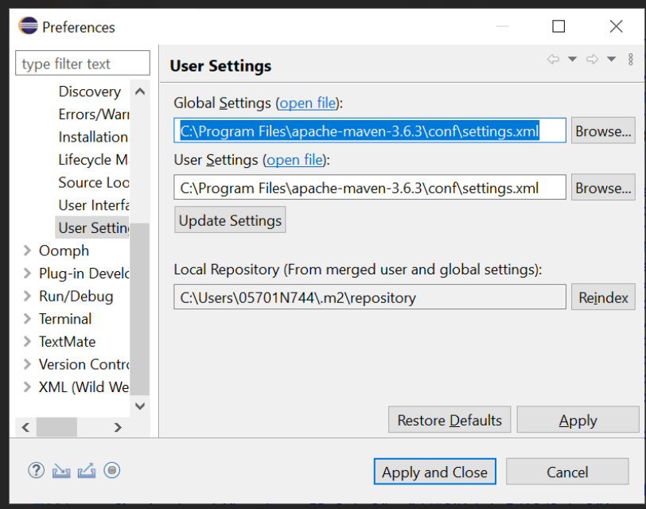
**** IMPORTANT****
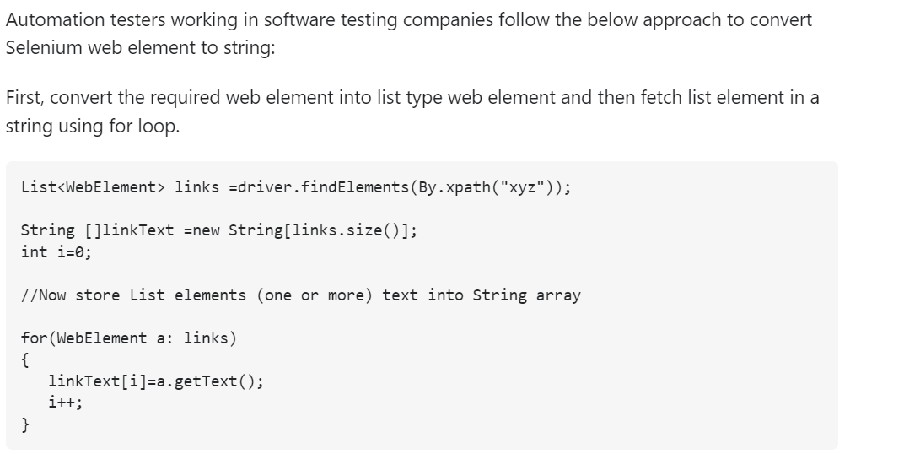

Sample code for finding cucumber from a page and adding to cart
List <WebElement> syntax
for(int i =0; i<webelement.size();i++){
String prodText = webelement.get(i).getText();
if (prodText.contains("Cucumber")){
// add to cart action
driver.findElements(xpath).get(i).click();
break;
}
}
Sample code for checking items from an array and add to cart
**define array of items needed
String[] items = {"Mango","Cucumber"};
List <WebElement> syntax
for(int i =0; i<webelement.size();i++){
String prodText = webelement.get(i).getText();
** make a arrayList in runtime to save memory space
List itemsNeeded = Array.asList(items);
if (itemsNeeded.contains("items")){
// add to cart action
driver.findElements(xpath).get(i).click();
// break won’t support arrayList
}
}
Sample code
import java.util.Arrays;
import java.util.List;
import java.util.concurrent.TimeUnit;
import org.openqa.selenium.By;
import org.openqa.selenium.WebDriver;
import org.openqa.selenium.WebElement;
import org.openqa.selenium.chrome.ChromeDriver;
import org.openqa.selenium.support.ui.ExpectedConditions;
import org.openqa.selenium.support.ui.WebDriverWait;
public class base {
public static void main(String[] args) throws InterruptedException {
System.setProperty("webdriver.chrome.driver", "C://chromedriver.exe");

WebDriver driver = new ChromeDriver();
String[] itemsNeeded = { "Cucumber", "Brocolli", "Beetroot" };
driver.get("https://rahulshettyacademy.com/seleniumPractise/");
Thread.sleep(3000);
addItems(driver, itemsNeeded);
}
public static void addItems(WebDriver driver, String[] itemsNeeded)
{
int j = 0;
List<WebElement> products = driver.findElements(By.cssSelector("h4.product-name"));
for (int i = 0; i < products.size(); i++)
{
//Brocolli - 1 Kg

//Brocolli, 1 kg

String[] name = products.get(i).getText().split("-");
String formattedName = name[0].trim();

//format it to get actual vegetable name

//convert array into array list for easy search

// check whether name you extracted is present in arrayList or not-

List itemsNeededList = Arrays.asList(itemsNeeded);
if (itemsNeededList.contains(formattedName))

{
j++;

//click on Add to cart

driver.findElements(By.xpath("//div[@class='product-action']/button")).get(i).click();

if (j == itemsNeeded.length)

{

break;

}

}

}

}

}

Calendar date code
import java.util.List;
import org.openqa.selenium.By;
import org.openqa.selenium.WebElement;
import org.openqa.selenium.chrome.ChromeDriver;
public class calendar {
public static void main(String[] args) {
// TODO Auto-generated method stub
System.setProperty("webdriver.chrome.driver", "C://work//chromedriver.exe");
ChromeDriver driver=new ChromeDriver();
driver.get("https://www.path2usa.com/travel-companions");
//April 23
driver.findElementByXPath(".//*[@id='travel_date']").click();
while(!driver.findElement(By.cssSelector("[class='datepicker-days'] [class='datepicker-switch']")).getText().contains("May"))
{
driver.findElement(By.cssSelector("[class='datepicker-days'] th[class='next']")).click();
}
List<WebElement> dates= driver.findElements(By.className("day"));
//Grab common attribute//Put into list and iterate
int count=driver.findElements(By.className("day")).size();
for(int i=0;i<count;i++)
{
String text=driver.findElements(By.className("day")).get(i).getText();
if(text.equalsIgnoreCase("21"))
{
driver.findElements(By.className("day")).get(i).click();
break;
}
}
}
}

